1 June 2007 The Weekly Bulletin of Rotary Club of Kathmandu Mid-Town Bc # 48 of 2006-07
Rotary Club of Kathmandu Mid-Town
Breakfast Chatter




District : 3290 Web: www.rotarymidtown.org.np Club Id : 26776

JUNE IS THE FELLOWSHIP MONTH
Rotary Fellowships . . .
. . . The Friend Makers !
Rotary Fellowships are groups of Rotarians with similar interests joined together by the first object of Rotary – Acquaintance. Fellowships become your personal connection with Rotary International.
Types of interest groups:
a) Sports & Games: chess, golf, cricket, canoeing, cycling, fishing, walking and jogging etc.
b) Hobbies: amateur astronomers, amateur radio, fine arts & antiques, fishing, fitness, flying, mountain climbing, handicrafts, home exchange, magic, music, travel and hosting, etc.
c) Service: computer users, disaster managers/responders, environment, travel and hosting etc.
d) Vocations: accountants, arts & communication, education – special, eye care professionals, finance/ banking, floral designers, nursing, paper industry, performing arts, stockbroker / securities industry, travel agents, etc.

Basanta R Kunwar, (former SSP) Executive Director, Narconon Nepal, talked about drug addiction,
a dangerous trap for Nepali youth, at the Club meeting on Friday, 25 May 2007.
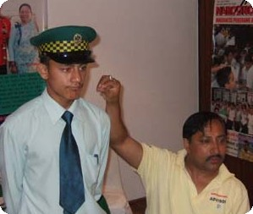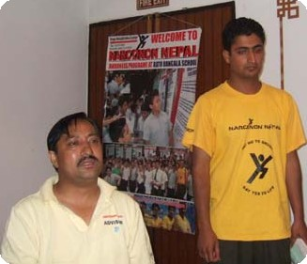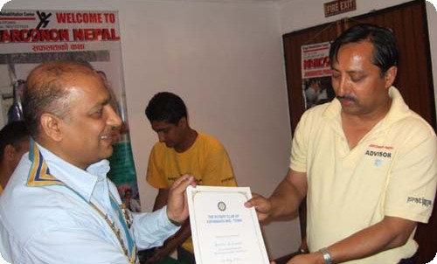
(a) Guest Speaker Kunwar presenting a drug addict student being cured in Narconon Nepal,
(b) Speaker Kunwar discussing on different aspects and dimensions of drug addiction in Nepal, and
(c) Speaker Basant Kunwar accepting a letter of appreciation from Club President CK Golchha.

Weekly Meetings and Programs :
Date | Program/Speaker | Program/Topics of Presentation
1 June 2007 | ?? | Nepal Bandh called by Janajatis
8 June 2007 | Dinner meeting
15 June 2007 | Joint meeting | Joint meeting with RC Rajdhani

Friday, 1 June :
Joint meeting with RC Rajdhani scheduled on Friday, 1 June is postponed due to proposed Nepal Bandh on that day, and is now rescheduled on Friday, 15 June 2007.

District Awards :
District Award Ceremony on Saturday, 26 May 2007 at Hotel Radisson, Lazimpat was a pleasant occasion for the Rotary Club of Kathmandu Mid-Town. The Club was successful in bagging many District Awards won on the basis of club activities, projects launched, programs handled, relationship maintained within and outside the Club, and host of other activities during the Rotary year 2006-07.
Awards the Club won during the occasion are listed below:

Best Club Award in Community Service;
Best Club Award in International Service;
Outstanding President Award to President CK Golchha;
Awards in Appreciation of Contribution towards making Rotary Year 2006/07 Successful:
PP Mani Dhoj Joshi, District Trainer
PP Gopal S. L. Kakshapati, District Secretary
PP William Ma, District Rotary Foundation Coordinator
PP Dr Chandra Lekha Tuladhar, Assistant Governor
PP Ajaya Sthapit, District Committee Chair
Special Recognition for Initiating Safe Motherhood Project: PP Hartmut Bauder;
Special Recognition for Hosting ICM (Membership Development);
Special Recognition for Hosting GSE Team.
Winner of:
First in Rotary Rotaract Relation;
First in Rotary Interact Relation;
First in Avoidable Blindness category;
First in Public Health category;
Second in Participation in District activities categories;
Second in Contributions to TRF;
Third in Membership Retention category;
Third in Rotary Image category;
Third in Career Counseling category;
Third in Literacy category;
Congratulations ! Congratulations to all ! Congratulations !

Giant hole in China :
Chinese, American and British scientists have discovered a giant hole in the ground in China, which has immediately been praised as a geological wonder and potential tourist attraction. The 300 meter deep barrel-shaped hole was found hidden in dense bamboo forest in Wulong county near south-western Chongqing municipality. At the bottom of the hole, the researchers found two water-eroded caves, extending for a total of 18 km. The hole is classified as a sinkhole which is a geological feature developed when limestone or a similar rock type is dissolved by groundwater and collapses.
Source: The Himalayan Times

On Lighter Side : Click at the figure ⇩


As Rotarians, we do not walk away from … tremendous challenges. Not only do we have that faith to believe we can make a difference, we have the courage to do. That courage is the difference between dreaming great dreams and putting them into action.
RI President William B. Boyd

1 June 2007 The Weekly Bulletin of Rotary Club of Kathmandu Mid-Town Bc # 48 of 2006-07

Editor: RR Shrestha, Club Service Director email: rryes@wlink.com.np

